Christopher Dechene
Professor Pettit
CS-320-T4513 Software Test Automation & QA 22EW4

While developing the mobile application software there also needed to be JUnit tests implemented in order to check that the software was behaving as intended. The customer had requirements that needed to be followed and the JUnit tests were created to make sure those requirements were functioning, one such example is in the contact test file where each string is being checked for its requirements. Every string from id to the address needed to be a specific length with the ID being under 10 digits, the phone number being exactly 10 digits and the address length being no greater than 30 characters.
public Contact(String id, String firstName, String lastName, String number, String address) {
if(id == null || id.length()> 10) {
throw new IllegalArgumentException("Invalid id");
}
if(firstName == null || firstName.length()> 10) {
throw new IllegalArgumentException("Invalid first name");
}
if(lastName == null || lastName.length()> 10) {
throw new IllegalArgumentException("Invalid last name");
}
if(number == null || number.length()< 10 || number.length()> 10) {
throw new IllegalArgumentException("Invalid number");
}
if(address == null || address.length()> 30) {
throw new IllegalArgumentException("Invalid address");
}

This section in the main Contact.java file checks the length of each of the strings and then will throw an illegal argument should they exceed the allowed length or if labeled null.
void testContactidTooLong() {
Assertions.assertThrows(IllegalArgumentException.class, () -> {
new Contact("01234567890", "Firstname01", "Lastname", "5551234567", "AddressofContact");
}); }

Then in the JUnit test, each section of the strings are tested should they have such exception of being too long (in this case the ID) or being null. To make sure that the code is technically sound the test needs to be looking for which part of the string to test. As shown above the test is checking for the ID to be too long. The string “01234567890” has 11 digits as opposed to the 10 that was established in (id.length() > 10) in the main Contact.java file.
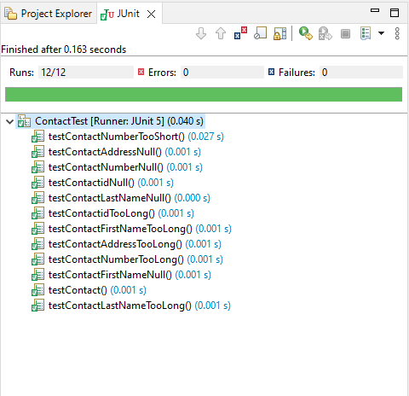
Going back to the Contact Test JUnit test we see here that each test in the contact runs and is successful. Correclty following the requirements of the program. In order for the code to be efficicent both the unit testing as well as the service files need to be in working order.
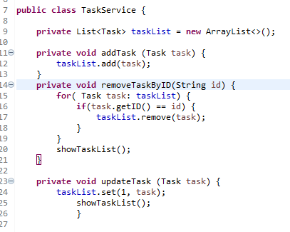

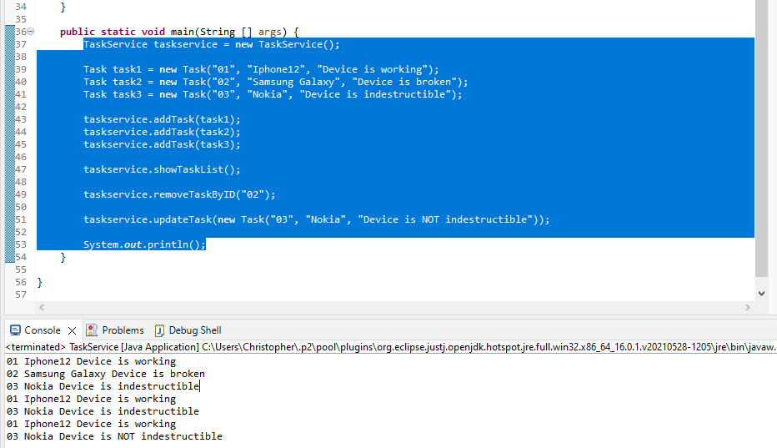
This example shows the Task.java file with the arraylist being implemented as well as the ability to add, update, and remove tasks by ID. This is part of the requirements for the program as stated. There is also an example of the main working as intended with the above code and below We see that the array lists are added and printed as shown.
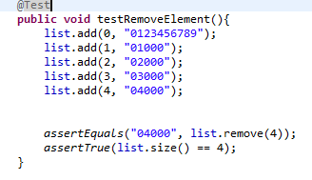
In this project there was a focus on “White Box Testing” in order to test the functionality of the program. Also known as Structure Based Testing which “are used to explore system or component structures at several levels.”. (Hambling, et al. 2015) It's one of various software testing techniques used in software development. This focus on White Box Testing was done with the JUnit tests mentioned earlier. Using another example from a unit test;
we see that the test removes element 4 from the test list implemented. This is one of the several tests done in the unit test to check that the software is behaving as required for the program. In these unit tests I also used the software testing technique known as “System Testing: which is mentioned in “Software Testing - An ISTQB-BCS Certified Tester Foundation Guide (3rd Edition)” “to consider the functionality from an end to end perspective”. (Hambling, et al. 2015) Or in other words System Testing is various tests that are performed for the functionality of the program. The unit tests have been a prime example of the idea of System Testing being that they are implemented to test the intended functionality of the program from checking if the stings are too long or short to testing to add and remove elements in the array lists in each java program. There are many other software development techniques used during the process that I myself have not used in this project, some such techniques are Integration Testing, “The purpose of integration testing is to expose defects in the interfaces and in the interactions between integrated components or systems.” (Hambling, et al. 2015) An example of Integration Testing can be logging into a mailbox. The test case can be entering the log in credentials to test that the mailbox accepts the information and will allow access into the mail box or to deny entry if these log in credentials are incorrect. Security testing is another technique that focuses on checking for any vulnerabilites within the system. It's to make sure that the program is capable of securing data with principles such as confidentiality, authorization, and authentication in order to make sure that the program is protected from any vulnerabilites should it be attempted to be attacked by any outside intruders (hackers).
In acting as a software tester I needed to be able to understand how each section of the code for the project functioned together to achieve the result of it all working together as intended. In this mobile application the client's requirements were based on adding, deleting, and updating various array lists with the established user ID for each section of the software. Each section had slightly different requirements such as having contact information and another was creating appointments but they all functioned the same so if one section could be understood then so could the rest of the application. In order for me to exercise caution I needed to not go above the intended requirements for the software. As mentioned each part of the software had its own requirements for what the client needed.
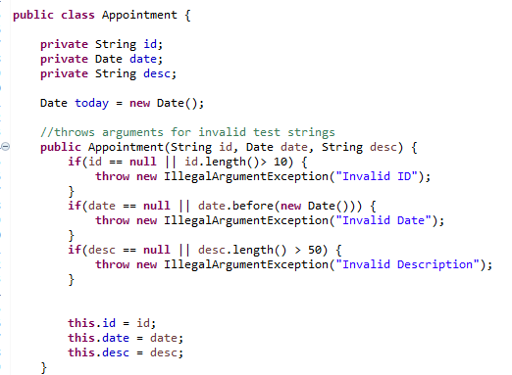
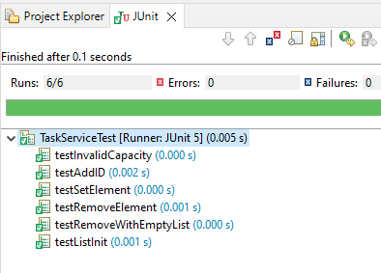
In this appointment class for example the string, date, and description are all requirements to be created for the list to create and accept appointments. I needed to make sure these requirements were kept intact and not neglected or gone way past what the client had requested. There is a bit of bias that can be in your mind when developing software. For me personally I just intend to make the software as requested but again going back to making sure the requirements are met. It is important to keep biases in check as I need to make sure that the tests are in working order. Without making sure that the tests are working properly I can let by possible exploits into the software and that turn a project whether my own or made for someone else into a possible danger from any hackers. Such negligence would be on my part and cannot be taken lightly. This is also a reason why I must also exercise disipline when creating software and testing. For the reason I just mentioned leaving vulnerabilites can lead to exploits and attacks from hackers which say if im working on software for a business can damage their reputation and even in severe cases end that business and put many of people out of work and even in danger due to sensitive data being in the hands of attackers. Which is why it is crutial as a software developer and tester that I do not become negligent in my work. I have to keep learning new techniques as well as properly testing code to ensure that my work is both functional and safe for use.

References
Hambling, Brian Morgan, Peter Samaroo, Angelina Thompson, Geoff Williams, Peter. (2015). Software Testing - An ISTQB-BCS Certified Tester Foundation Guide (3rd Edition). BCS The Chartered Institute for IT. Retrieved from
https://app.knovel.com/hotlink/toc/id:kpSTAIST01/software-testing-an-istqb/software-testing-an-istqb

